March 2020 Newsletter

Office Hours
The office is open from 8:00 a.m. to 3:00 p.m. on Monday, Tuesday, Thursday, and Friday.
Office phone number is 972-442-6875 Email: District@slud.us
Upcoming Meetings
Board meetings are held on the third Monday of each month @ 7:30 p.m. in the Seis Lagos Community Clubhouse. The meetings are open to the public and we welcome you to attend.
E-Billing Notifications
E-Billing saves time, paper and money by emailing residents their Utility Bill. Please sign up for E-Billing by emailing SLUD at District@slud.us *Include your name, address, and contact information.

IMPORTANT NEWS AND REMINDERS
We have an updated website! Check it out at www.slud.us There has been no change to our site name address, just a new look on the website.

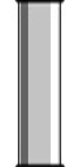
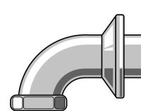
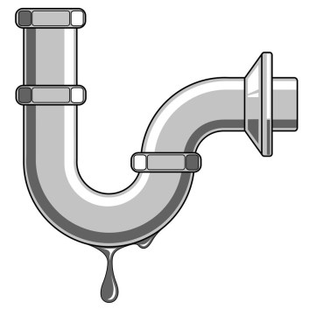
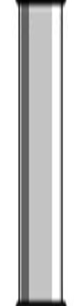
Backups and clogged drains can be detrimental to sewer systems, and they may be caused by daily household items! They create cement-like blocks inside pipes.
Did You Know?
Some of these items are:
- Frying pan oils
- Egg shells
- Baby wipes
- Sauces, gravy, and dressings
- Greasy or fried foods

Meter Reading Dates and Information
Meter reading is on the 28th of each month; if the 28th is on a Saturday or Sunday, meters will be read the Friday preceding the 28th.
Utility bills will be mailed by the first of each month and are due no later than 8:00 a.m. on the 16th of every month.
The District is not responsible for delays in delivery by the Post Office. Bills postmarked after the 16th will be considered delinquent.
A ten percent (10%) late payment fee will be added to the account after 8:00 a.m. on the 16th of the month.
Past due notices will be mailed on the 16th of the month; if the 16th is on Saturday or Sunday, past due notices will be mailed the next business day following the 16th and allowing water service to continue until 8:00 a.m. on the 28th of the month (13 days past due).
If full payment is not received the meter will be locked and $120.00 fee will be added to the account. The account will need to be paid in full to restore service.
Payment Methods:
- Pay by check via mail or the drop box by the clubhouse.
- Use ACH –Direct Withdrawal
- Online payment system on the SLUD website at http://www.slud.us/bill-payment.
- Drop off payment at the SLUD office.
- Automatic Bill Pay - For more details contact the SLUD office

SWIMMING POOL INSTALLATION AND CONSTRUCTION REMINDER:
If you have installed a swimming pool within the past 2 years and did not contact SLUD prior to construction, please contact our office to schedule an inspection. You are subject to disconnection of service and your meter pulled out of the ground. We require that you complete a Contractor Permit & Deposit Agreement at the business office prior to any construction commencing. A deposit of $2,000.00 is required (refundable “if” the road is not damaged), as well as a non-refundable inspection fee of $60.00
Utilization of concrete trucks, eighteen (18) wheelers, dump trucks or heavy equipment require a Contractor Permit & Deposit Agreement and a deposit of $2,000.00 prior to commencing any work. Roads will be inspected prior to any work commencing and a final inspection of the road will be assessed upon completion of your project. If there is no damage to the road, a check will be issued by SLUD for a full return of the deposit. Please allow no less than seven (7) business days for your refund check to be processed. If any work proceeds without meeting these requirements, a non-refundable charge of $3,000.00 be issued (individual charge of $3,000.00 per lot if multiple lots). This information may be found in the Rates & Rules, Sections 6.8. and 5.1.

